# **How To Attach And Mount An EFS To EC2 Linux Instance**

1. Login to AWS web console
2. Select **Elastic File System**
3. Select **Create file system**
4. Select **VPC**
5. Select Private subnets that the EC2 Instances are on for the availability zones
6. Remove the default security group from each availability zone
7. Paste or start typing the EFS Security Group ID in for each availability zone
8. Select **Next Step**
9. Add Name Tag and any others
10. Select Generic or Max I/O type
11. Select **Next Step**
12. Select **Create file system**

 Search the EFS (managed file storage for EC2) from services

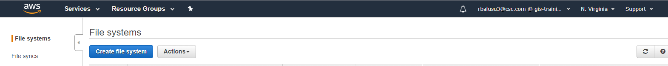

**Step 2:** Click on create file system from above screen

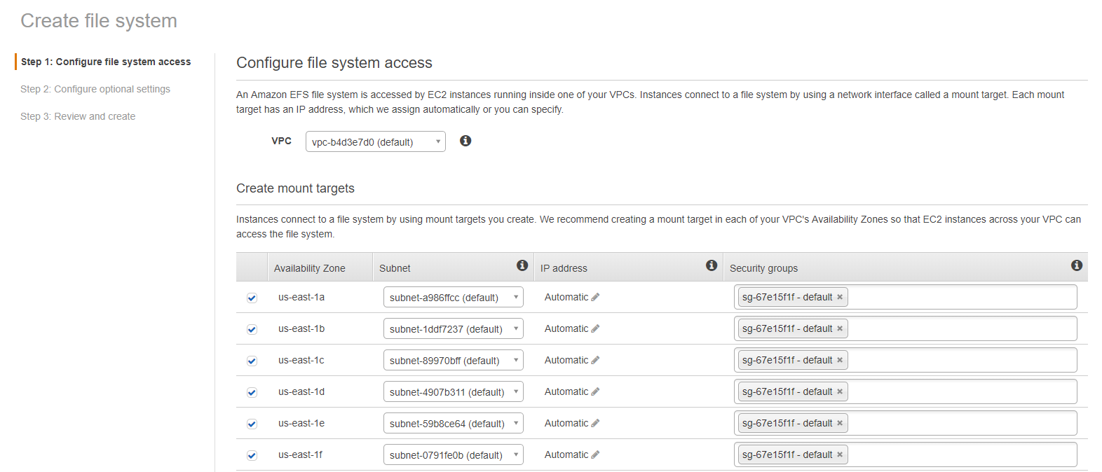

Select the VPC and select the availability zones from the list

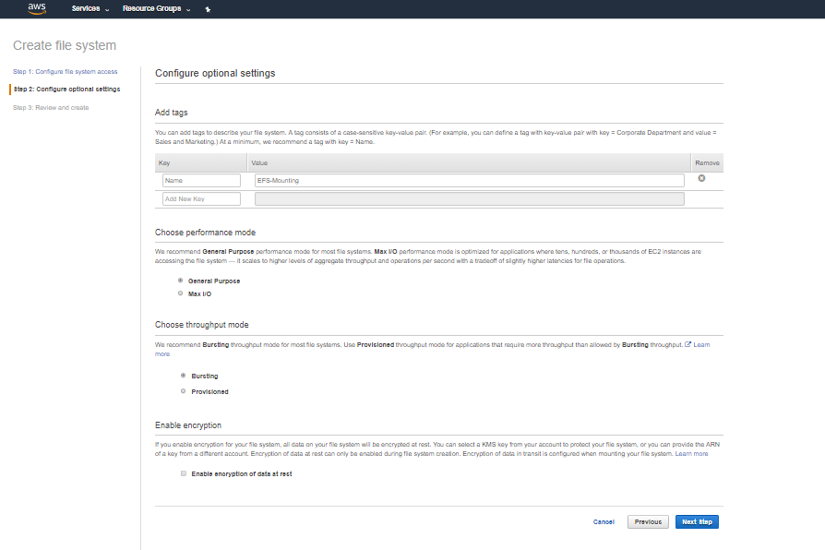

Enter the value for choose the other values and click on next

**Step 3: Review the changes and click on crate file system**

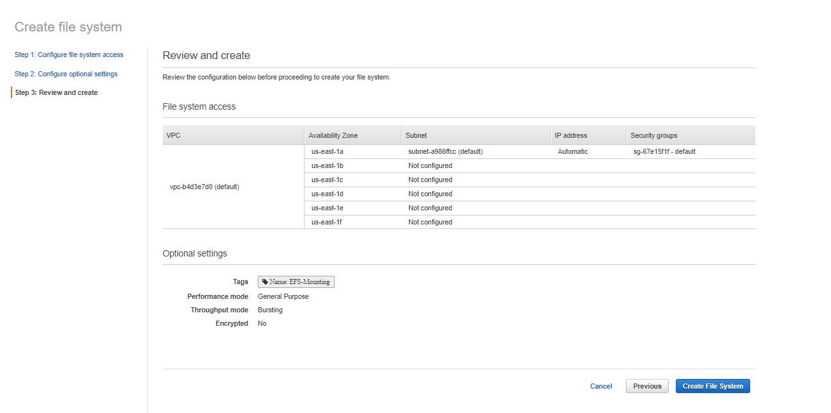

**Step 4:** Install Dependencies

Launch your EC2 instance and install the following dependencies

1. NFS utilities
   1. sudo yum -y install nfs-utils
2. amazon-efs-utlis
3. sudo yum -y install git
4. git clone <https://github.com/aws/efs-utils>
5. Because you need the bash command make, you can install it with the following command if your operating system doesn't already have it.
6. sudo yum -y install make
7. After you clone the package, you can build and install amazon-efs-utils using one of the following methods, depending on the package type supported by your Linux distribution:
8. RPM – This package type is supported by Amazon Linux, Red Hat Linux, CentOS, and similar.
9. DEB – This package type is supported by Ubuntu, Debian, and similar.

To build and install amazon-efs-utils as an RPM package

1. Open a terminal on your client and navigate to the directory that has the cloned amazon-efs-utils package from GitHub (for example "/home/centos/efs-utils").
2. If you haven't done so already, install the rpm-builder package with the following command.
3. sudo yum -y install rpm-build
4. Build the package with the following command.

sudo make rpm

1. Install the amazon-efs-utils package with the following command.
2. sudo yum -y install ./build/amazon-efs-utils*rpm

**Step 5 –** Get DNS URL

1. Open EFS Web Console
2. Select the newly created EFS
3. Click on the DNS Names hyperlink on bottom left

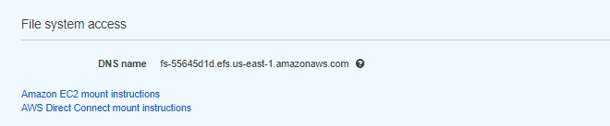

**Step 6 :** Manual Mount

Use the below command for manual mount.

sudo mount -t nfs4 -o nfsvers=4.1,rsize=1048576,wsize=1048576,hard,timeo=600,retrans=2,noresvport fs-55645d1d.efs.us-east-1.amazonaws.com:/ efs

type df -h command you can see the mount attached to efs**.**

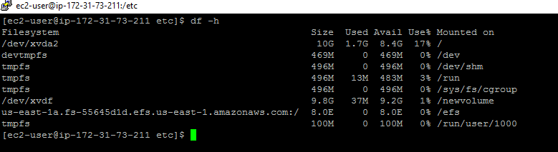

**Step 7: Auto mount**

**If you reboot the system and the mount will be deleted and if the mount make available even the system reboot , we need to update the fstab file.**

**.1. take the backup of fstab file (\etc\fstab)**

**Cp fstab fstab.bak**

1. **Open the fstab file add the below line and save the file.**

**mount-target-DNS:/ efs-mount-point nfs4 nfsvers=4.1,rsize=1048576,wsize=1048576,hard,timeo=600,retrans=2,_netdev,noresvport 0 0**

**us-east-1a.fs-55645d1d.efs.us-east-1.amazonaws.com:/ /efs nfs4 nfsvers=4.1,rsize=1048576,wsize=1048576,hard,timeo=600,retrans=2 0 0**

1. **Reboot the system using sudo reboot command and run the df -h command you can see the mount point and it will not be deleted.**

